Fossil-Stromatolite-Conophyton-Morocco- Boulalou

*Stromatolite*, probably *Conophyton*, from Morocco, Lower Ordovician (500 million years old), from the Boulalou region of Morocco. about 4.5" in diameter and is about 4.25" deep. Stromatolites are comprised of blue-green algae, a very ancient photosynthesing organism, which grew in large mats and cone-shaped structures. They were most prevalent during the Pre-Cambrian, from a time that Prokaryotic life forms no longer had exclusive use of earth's shorelines. The earth’s coastal habitats had markedly reduced stromatolite reefs, compared with the Proterozoic. The form genera is conophyton, denoting successive laminae with an overall conical shape. By the Lower Ordovician, microbial communities consisted of complex consortia of both prokaryotic and eukaryotic forms with diverse metabolic needs, and competition for resources and differing motility among them made for an intriguing microcosm of interacting life, some autotrophic, some chemotrophic and some heterotrophic. However, stromatolite reefs are believed to have regained a temporary foothold following extinctions that concluded the Cambrian Period. Since these stromatolites date from the Lower Ordovician, they may well have been part of the resurgence when predation by other organisms was temporarily, at least, suppressed.

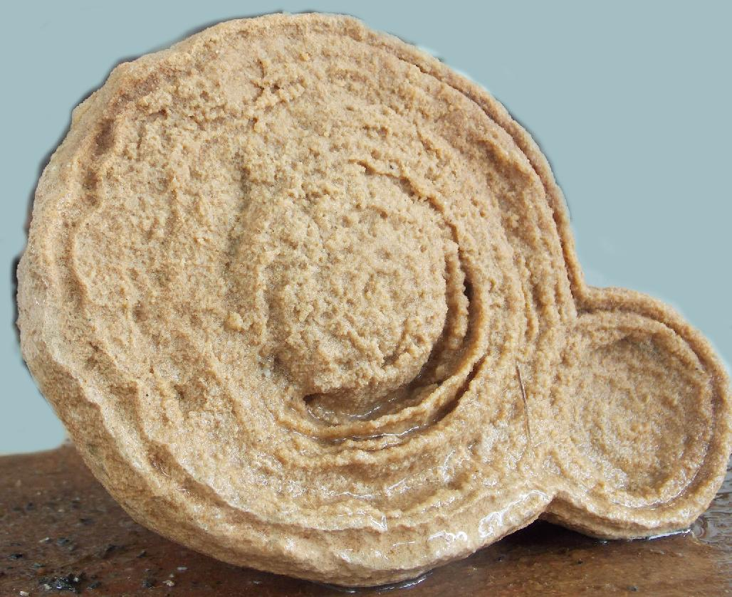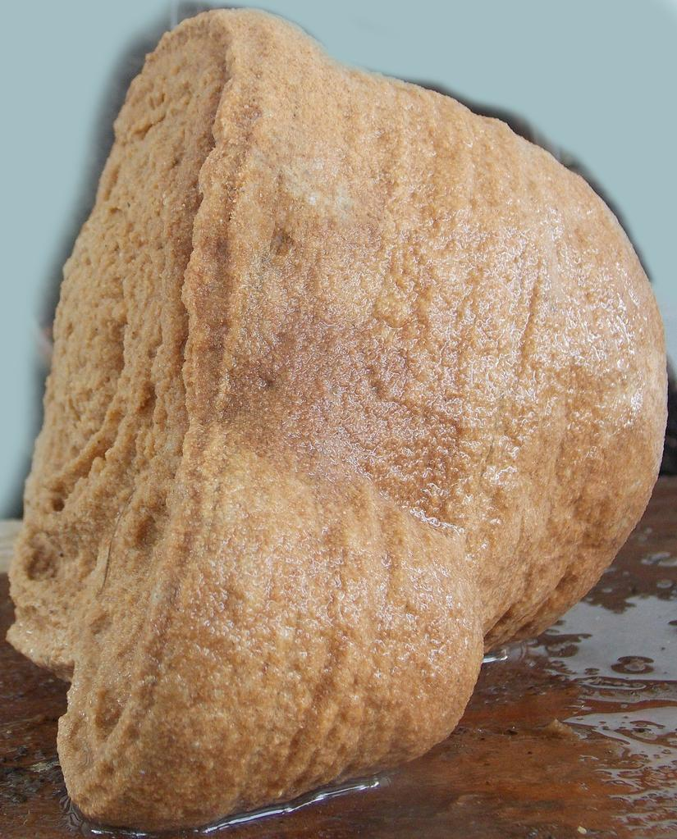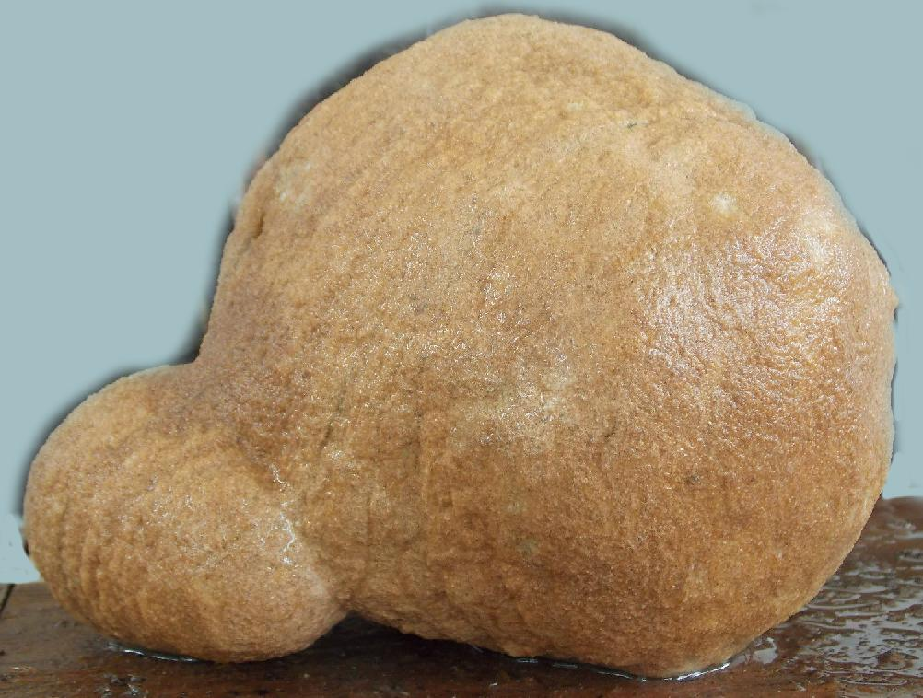

about   2.75  oz.   and measures about 3 x 1 x  1".

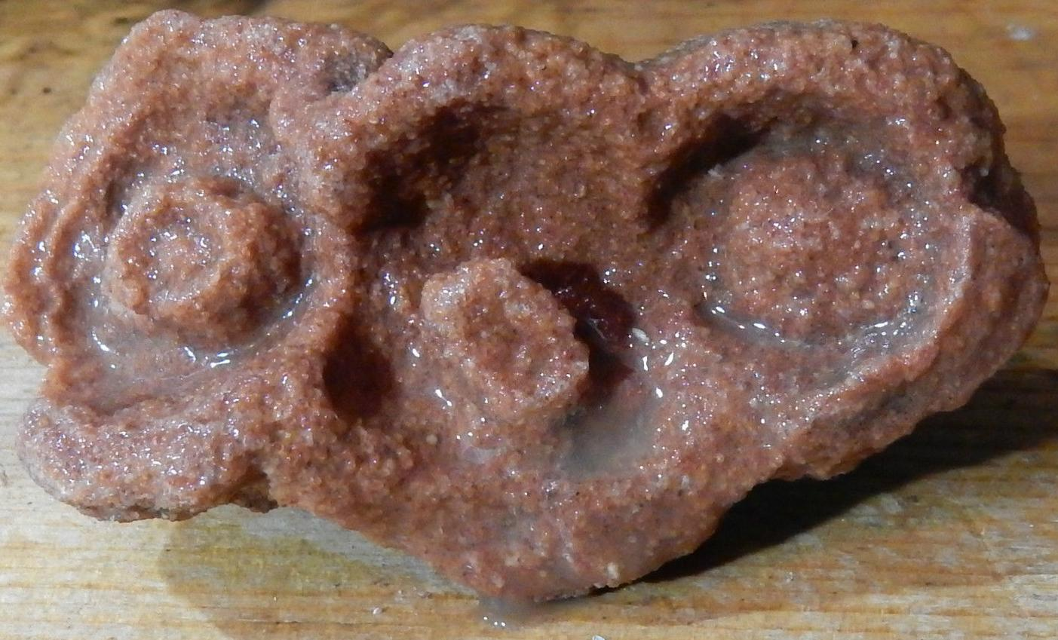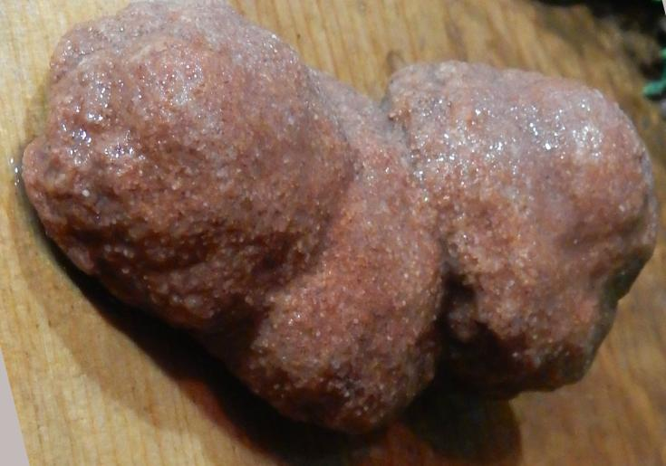

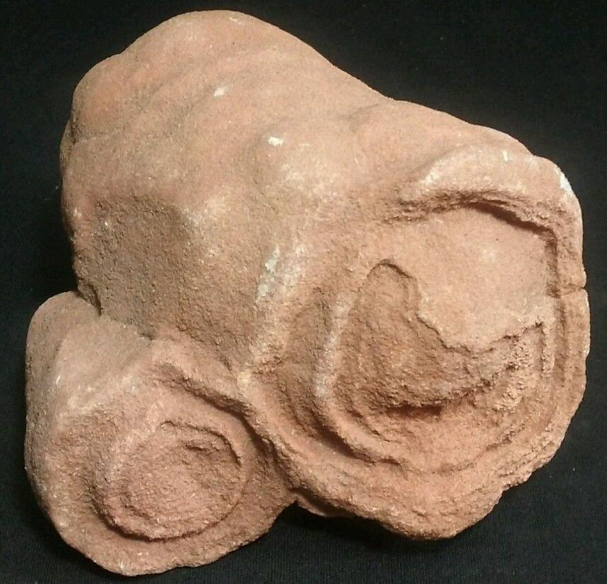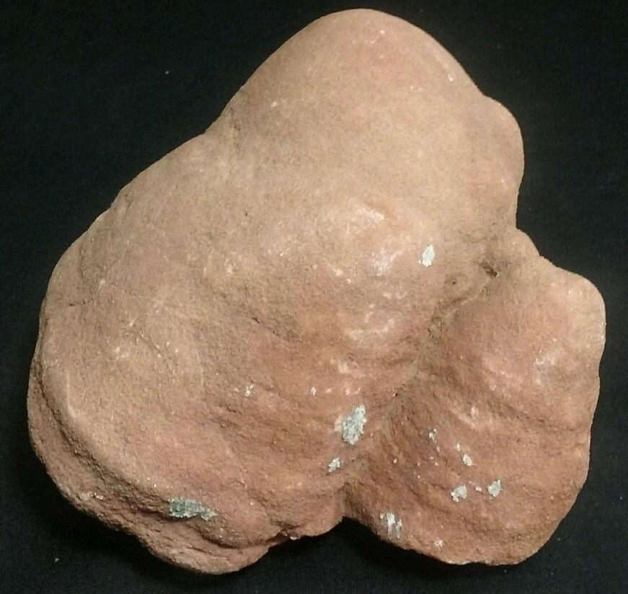

Sold by [grandmuddy3344](http://myworld.ebay.com/grandmuddy3344) ( [7106](http://feedback.ebay.com/ws/eBayISAPI.dll?ViewFeedback&userid=grandmuddy3344) )

### Delivery package 1 of 1

Estimated delivery Wednesday, Jan 6, 2016

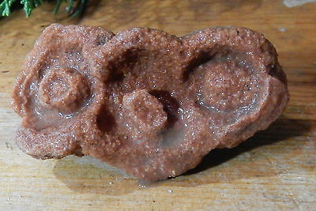

#### [Stromatolite-Fossil Algae-Oldest Life Form-Sahara, Morocco](http://www.ebay.com/itm/311503559657)

|  |  |
| --- | --- |
| Item price | $8.25 |
| Quantity | 1 |
| Item number | 311503559657 |
| Shipping service | USPS First Class Package |

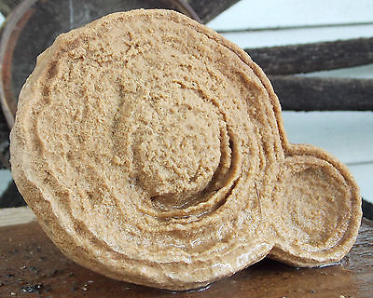

#### [Stromatolite-Fossil Algae-Oldest Life Form-Sahara, Morocco](http://www.ebay.com/itm/262193323151)

|  |  |
| --- | --- |
| Item price | $57.50 |
| Quantity | 1 |
| Item number | 262193323151 |
| Shipping service | USPS Priority Mail Medium Flat Rate Box |